ASYMMETRY OF PHOTOELECTRON DISTRIBUTION AND ITS DEPENDENCE ON SPACECRAFT POTENTIAL OBTAINED FROM GEOTAIL DATA

Tadahiro Shimoda^{a,c}, Shinobu Machidaª, Toshifumi Mukai^{b}, Yoshifumi Saito^{b},
Yasumasa Kasaba^{b}, and Hajime Hayakawa^{b}

ª Kyoto University, Kitashirakawa Oiwake-cho, Sakyo-ku, Kyoto 606-8502, Japan
^{b} Institute of Space and Astronautical Science (ISAS), Japan Aerospace Exploration Agency (JAXA), 3-1-1 Yoshinodai Sagamihara, Kanagawa 229-8510, Japan

^{c} Phone: +81-75-753-3956, FAX: +81-75-722-7884, E-mail: shimoda@kugi.kyoto-u.ac.jp

Abstract
In the Earth's magnetosphere where the spacecraft potential is usually positive, photoelectrons emitted from the spacecraft surface are attracted back to the spacecraft and some of them are detected by electron analyzer onboard. Then photoelectrons are unnecessary contamination. By analyzing such a component detected by LEP/EA-e onboard GEOTAIL spacecraft, we examined velocity/energy distribution functions of photoelectrons, and their relationship to the spacecraft potential.
We found that the ratio of the duskward photoelectron flux to the dawnward flux increases when the spacecraft potential is large, and decreases when it is small. Further analysis revealed, by plotting the ratio as a function of the photoelectron energy normalized by the spacecraft potential (E/V_{sc}), that it is the largest when E/V_{sc} is about one third. This result implies the existence of azimuthal component of electric field as well as the radial component which is regarded to be dominant in an ordinary case around the spacecraft surface, although it is not clear why such an electric field is generated around GEOTAIL.

1. Introduction
Photoelectrons are emitted from the sunlit surface of spacecraft by incident solar ultraviolet rays, thereby the spacecraft charging occurs. The spacecraft potential on a conductive surface is determined by the balance of currents carried by emitted photoelectrons and secondary electrons, ambient electrons, and ions impinging on the surface. In Earth's magnetosphere, the potential ranges from several volts to 100 volts of positive polarity relative to the space.
Therefore the spacecraft-originated electrons form an electron sheath around the spacecraft and they disturb the distribution of ambient plasma around the spacecraft. In-situ measurements of space plasma are affected by these electrons as well as the spacecraft potential. For instance, the spacecraft-originated electrons whose energies are less than the spacecraft potential are attracted by the spacecraft surface and they cause a contamination of particle data measured by electrostatic analyzer. In addition, the spacecraft surface attracts the ambient electrons of very low temperature (core electrons) and their velocity distribution is strongly modified. Pedersen et al. (1998) suggested that the offset of electric field data measured by ISEE-1 is attributed to non-uniform distribution of photoelectrons. Thus it is important to study the spacecraft-originated electrons and their effect to the space plasma measurements.
The photoelectron current around GEOTAIL spacecraft was studied by Nakagawa et al. (2000). They estimated the number density of photoelectrons on the spacecraft surface to be $2\text{.}9±1\text{.}4⋅{\text{10}}^{9}$ m⁻³ and their average energy to be $2\text{.}1±0\text{.}5$ eV, which are consistent with previous measurements by GEOS-1, ISEE-1 and Viking (Harvey et al., 1978, Hilgers et al., 1992, and Pedersen, 1995). Thiébault et al. (2004) studied the electron sheath around an idealized spherical spacecraft numerically and they showed the two-dimensional potential structure around the spacecraft. However, the distribution of photoelectron flux around the spacecraft has not been studied yet.
In this study, the two-dimensional photoelectron distribution around GEOTAIL spacecraft is studied by using the data from the electrostatic analyzer for electrons and from the electric field probe.

2. GEOTAIL spacecraft
GEOTAIL spacecraft, whose primary purpose was to study the magnetotail of the Earth, was launched on Jul. 24, 1992. As shown in Figure 1, it has a cylindrical body with diameter of 2.2 meters and height of 1.6 meters. Two masts which are six meters long are deployed symmetrically to separate the magnetometers from its body and four fifty-meter-long wires are deployed to measure electric field (Nishida, 1994). The surface of the spacecraft body is equipotential since it is coated with conductive indium oxide (InO₃).
Photoelectron distribution and spacecraft potential of GEOTAIL spacecraft are obtained from the data of the low energy particle (LEP) instrument and the electric field detector (EFD).
The LEP instrument (Mukai et al., 1994) measures the three-dimensional phase space distribution of ions and electrons in every 12 seconds. It consists of the energy-per-charge analyzer for electrons (EA-e), for ions (EA-i) and the
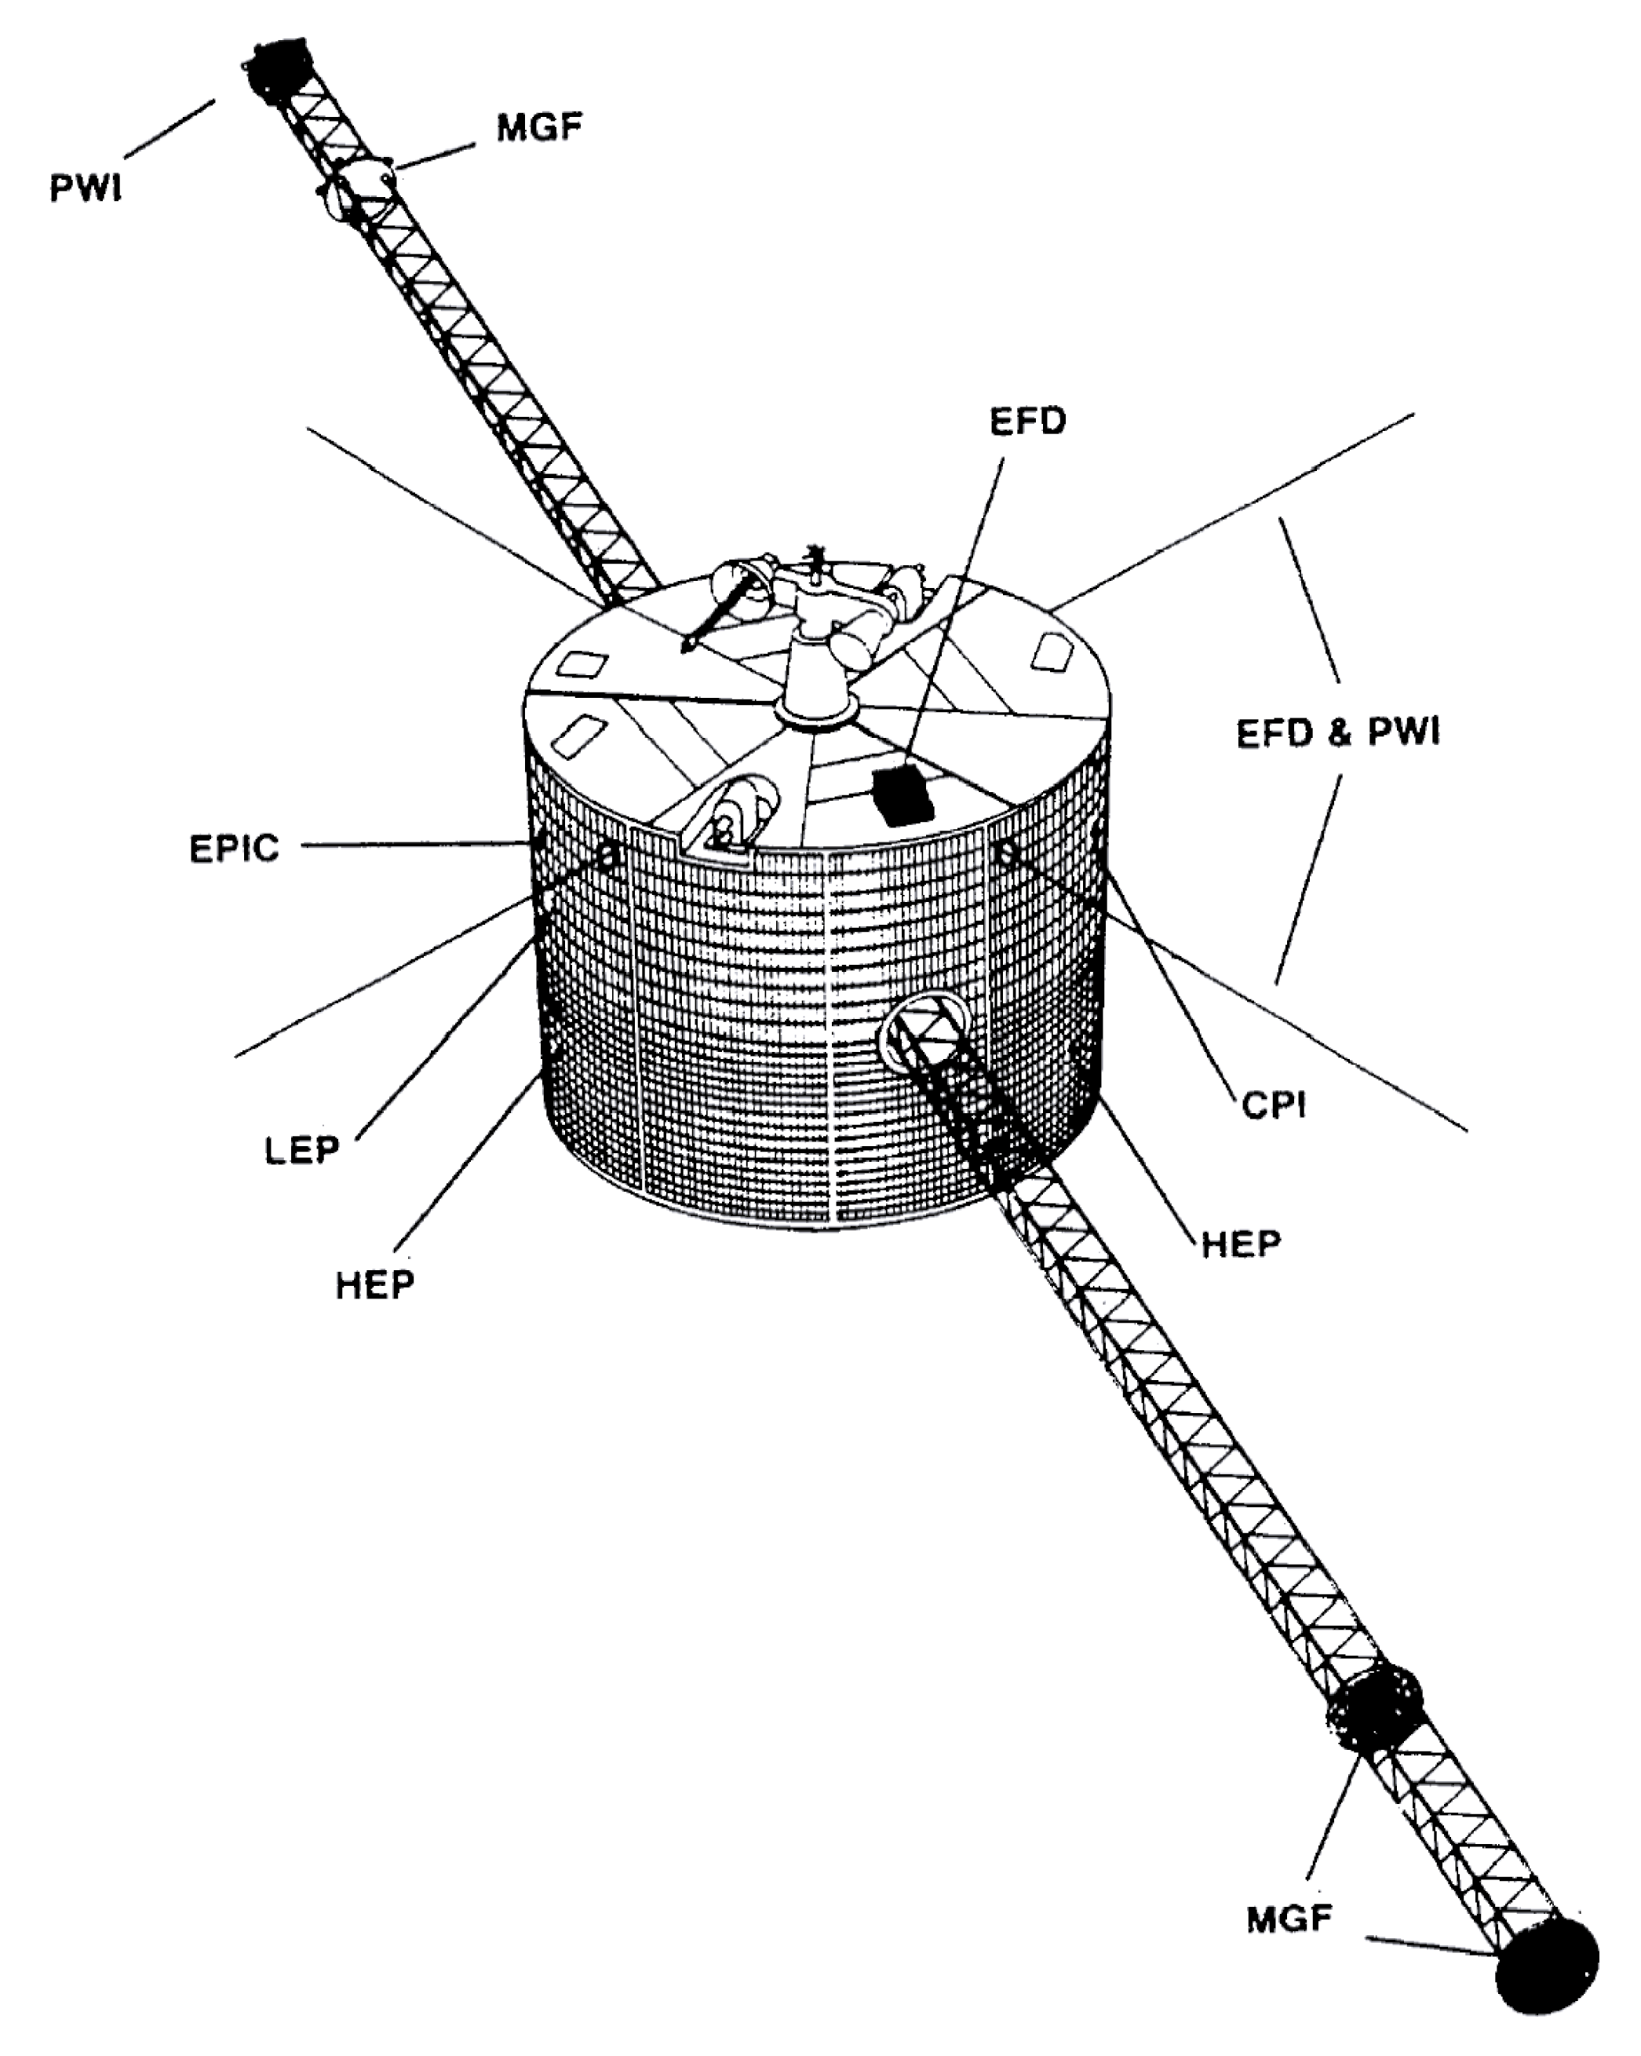

Figure 1. An overview of GEOTAIL spacecraft (after Nishida et al., 1994).

solar wind ion analyzer (SW). Their entrances are deployed on the spacecraft surface. The fields-of-view of EA-e and EA-i are both 145${}^{∘}×$360${}^{∘}$ in elevational and azimuthal directions and they are divided into seven elevation channels, 16 azimuthal sectors, and 32 energy steps. Their azimuthal 2$π$ fields-of-view are swept by the spacecraft spin. Macroscopic parameters such as density, bulk velocity and temperature are obtained from each sampling of the phase space distribution. All LEP units have two observational modes, RAM-A and RAM-B. They cover different energy ranges, from 60 eV to 38 keV and from 8.3 eV to 7.6 keV for RAM-A and RAM-B of EA-e. Since we are interested in photoelectrons from the spacecraft surface, only RAM-B data of EA-e are used.
The EFD instrument (Tsuruda et al., 1994) measures the electric field in the plasma by probe technique. It measures the potential difference between the spacecraft body and the tips of four wires. Wires are 0.45 mm in diameter and their surface are coated with Polyimide film of 0.12 mm thick for insulation except the outermost part of 1 m length. The end of wires are electrically biased so as to keep the potential of the end of wires and ambient plasma close within a few volts. The spacecraft potential is obtained by a pair of wires which have conductive spheres at their ends.
Figure 2 shows the deployment of the LEP instrument, two masts (FMST, SMST) and four wires (PANT-A/B, WANT-A/B).

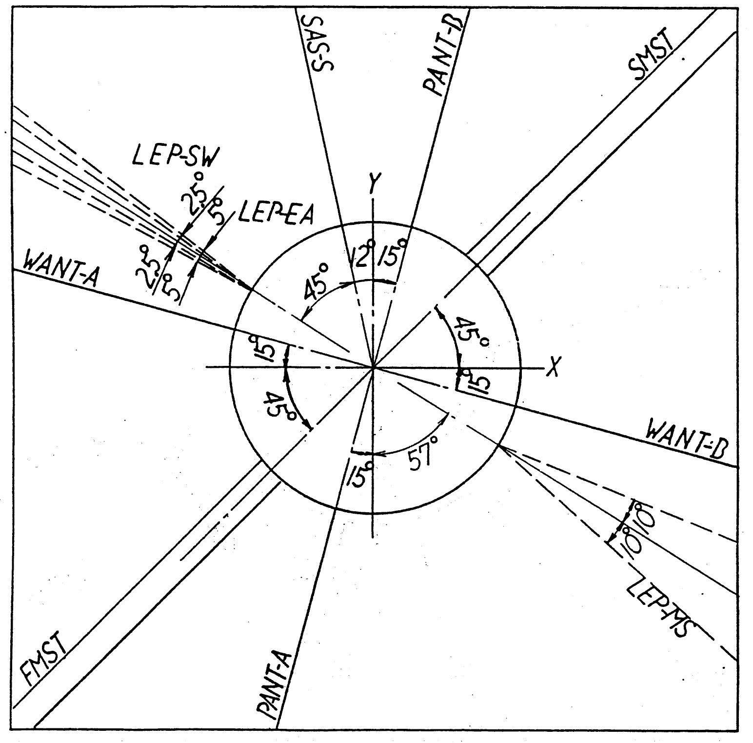
Figure 2. Deployment of LEP, two masts and four wires in a top-view (after ISAS Data Center, 1992)

3. Event Study
Figure 3 shows the data obtained by GEOTAIL spacecraft on January 11, 1993, from 1045UT to 1115UT. The spacecraft was located at (X, Y, Z)_{GSM} = (-44, 3, -6)R_{E}, where the Geocentric Solar Magnetospheric (GSM) coordinate system is used and R_{E} is the earth radius. Each panel presents, from top to bottom, Energy-time (E-t) diagram of tailward, dawnward, sunward and duskward electron counting rate, and spacecraft potential (bottom). Intense

Figure 3. Energy distributions of electrons and spacecraft potential at 1045-1115UT on Jan 11, 1995. From first to fourth panels indicate energy distribution of electrons traveling tailward, dawnward, sunward and duskward, respectively. The fifth panel is plot for spacecraft potential (Courtesy of D. Nagata).

low-energy electrons are spacecraft-originated photoelectrons and the upper cutoff energy of photoelectrons corresponds to the spacecraft potential.
Throughout the period shown in Figure 3, the duskward photoelectrons had higher counting rate than dawnward photoelectrons, namely, the dawn-dusk asymmetry of photoelectron population was present. There is also a day-night asymmetry as can be easily expected. The dawn-dusk asymmetry tends to become weak when the spacecraft potential is low, such as in the time interval of 1058-1106UT when the spacecraft is in the plasma sheet. This result suggests that the photoelectron distribution significantly depends on spacecraft potential.

4. Statistical Results
To examine the relationship between the photoelectron distribution around GEOTAIL and the spacecraft potential, we carried out statistical analysis. We used the data obtained from Sep., 1993 to Jun., 1997, and selected the data when the LEP/EA-e worked in RAM-B (low energy) mode and also GEOTAIL was sunlit in the magnetosphere. We excluded the data when it was in the magnetosheath or the solar wind, which satisfied the following all conditions similar to those adopted by Nakamura et al. (1997), but with some modification. The conditions are that ion density is larger than 0.5 cm⁻³, the tailward component of the ion velocity is larger than 200 km/s, ion temperature is less than 400 eV, and that the ion dynamic pressure is larger than 0.5 nPa. As many as 168,166 samplings were selected and the spacecraft locations at which the selected data were obtained were shown in Figure 4, indicating that the selected data were obtained in wide regions of the magnetosphere.
After extracting data, we sorted them by spacecraft potential with one-volt bin and calculated the averaged differential flux for each energy step from 8 eV to 60 eV of all sectors. In this paper, we only studied two-dimensional photoelectron distribution, so that, only electrons whose velocities are on a plane perpendicular to the spacecraft spin-axis, were shown.
Averaged differential fluxes for three cases of spacecraft potential (a) 12-13V, (b) 29-30V and (c) 50-51V, are shown in Figure 5. These three panels show that the ratio of tailward photoelectron flux to sunward photoelectron flux is large when the spacecraft potential is high, as well as when the electron energy is small. The duskward photoelectron flux (Sector 9 and its neighbors) is larger than the dawnward photoelectron flux (Sector 1 and its neighbors). In addition, the
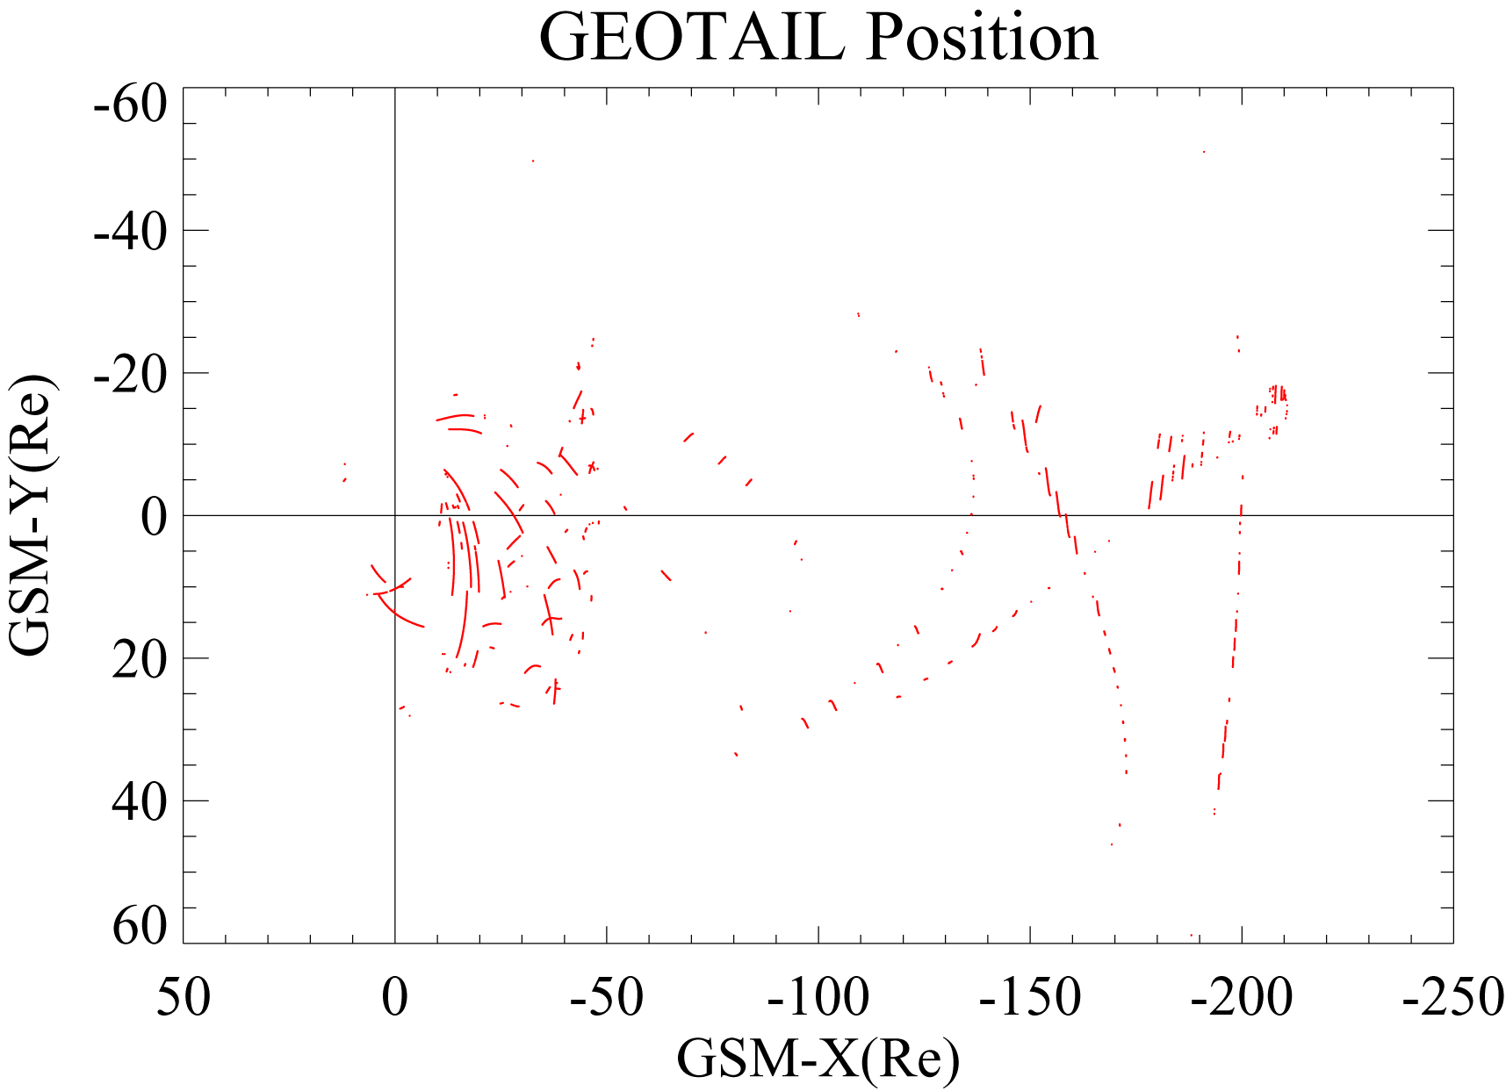

Figure 4. Location of GEOTAIL spacecraft in GSM coordinates when the selected data were obtained.

dawn-dusk asymmetry appears strongly in specific energy, 8.3 eV for panel (a), 10.3 eV for (b) and 16.0 eV for (c). These energies correspond to about one third of the spacecraft potential except the case of (a), since 8.3 eV is the lowest detectable energy for the LEP/EA-e. These facts suggest that the photoelectron asymmetry is regulated by the ratio of the photoelectron energy to the spacecraft potential (E₀/V_{sc}) rather than the spacecraft potential itself.
Therefore we examined the relation between photoelectron distribution and E₀/V_{sc} using all selected data which were used in the previous analysis, and the result is shown in Figure 6. Two scatter plots indicate (a) the ratio of duskward electron flux to dawnward flux (J_{sect9}/J_{sect1}), and (b) tailward flux to sunward flux (J_{sect13}/J_{sect5}), both as a function of E₀/V_{sc}. It can be seen that J_{sect9}/J_{sect1} and J_{sect13}/J_{sect5} have clear dependence on E₀/V_{sc} when E₀/V_{sc} < 1, although their values somehow spread. This clear dependence suggests that the asymmetry of photoelectron distribution is due to the electric field of the spacecraft potential. The value of J_{sect9}/J_{sect1} is largest and about 10 at E₀/V_{sc} = 0.3. On the other hand, J_{sect13}/J_{sect5} monotonically decreases as E₀/V_{sc} increases. The dependence of photoelectron distribution on E₀/V_{sc}, shown in Figure 6 is consistent with Figure 3.

5. Discussion
In this study, we found that the photoelectron distribution around GEOTAIL spacecraft is asymmetric in the dawn-dusk direction and that it depends on the ratio of photoelectron energy to the spacecraft potential. These facts suggest that there is an electric field in the azimuthal direction around GEOTAIL. Since this asymmetry depends on E₀/V_{sc}, this electric field is proportional to the spacecraft potential. With those facts, we think that this asymmetry is attributable to the spacecraft charging.
The characteristics of photoelectron distribution and its dependence on E₀/V_{sc} shown in Figure 6 can be explained as follows. Photoelectrons whose energies are much lower than the spacecraft potential are attracted back to the spacecraft surface soon after they are emitted, without being dragged dawnward by such electric field. Therefore dawn-dusk asymmetry is weak and day-night asymmetry is strongly appeared in such an energy range. On the other hand, photoelectrons which have energies about one third of the spacecraft potential, are effectively dragged by such an electric field. This results in a strong dawn-dusk asymmetry and weaker day-night asymmetry.
However there are other possibilities which cause the asymmetry, namely electron gyromotions due to the ambient magnetic field and the effect of the ambient electric field.
First, we consider the gyromotion of electrons caused by the ambient magnetic field. Charged particles in a magnetic field gyrate around the magnetic field and this gyromotion can transport photoelectrons from the sunward sector to the dawnward sector. Electron gyroradius (r_{c}) is represented as $r_{c}=3\text{.}4⋅{\text{10}}^{{}_{3}}{\sqrt{K}}/B$[m], where K and B denote the electron energy in eV and the magnitude of the ambient magnetic field in nT, respectively. In lobe region of Earth’s magnetosphere, the magnetic field intensity is 30 nT. Then r_{c}110 m for 1 eV electrons, which is much larger than the size of spacecraft body. Thus the effect of gyromotion can be negligible for the dawn-dusk anisotropy of photoelectron distribution.
Second, the effect of the ambient electric field is considered. There is a duskward electric field in the magnetosphere and its magnitude is about 0.1 to 1 mV/m. Photoelectrons may flow in dawnward by such electric field. Yet, there is also a radial electric field generated by spacecraft potential. Therefore the ambient electric field should be larger than such a radial electric field when the ambient field works effectively. The magnitude of such radial electric field is estimated to be ${V_{\text{sc}}}/{λ_{D}}$, where $λ_{D}$ is the Debye length. Around the spacecraft, both photoelectrons and ambient electrons contribute to the Debye shielding of spacecraft potential. However photoelectrons work much dominantly,
(a)

(b) (c)

Figure 5. Electron differential flux on the plane perpendicular to the spin axis of GEOTAIL for different spacecraft potential. (a) 12V < V_{sc} < 13V (b) 29V < V_{sc} < 30V (c) 50V < V_{sc} < 51V. Sector 1, 5, 9, and 13 correspond to dawnward, sunward, duskward, and tailward flux.

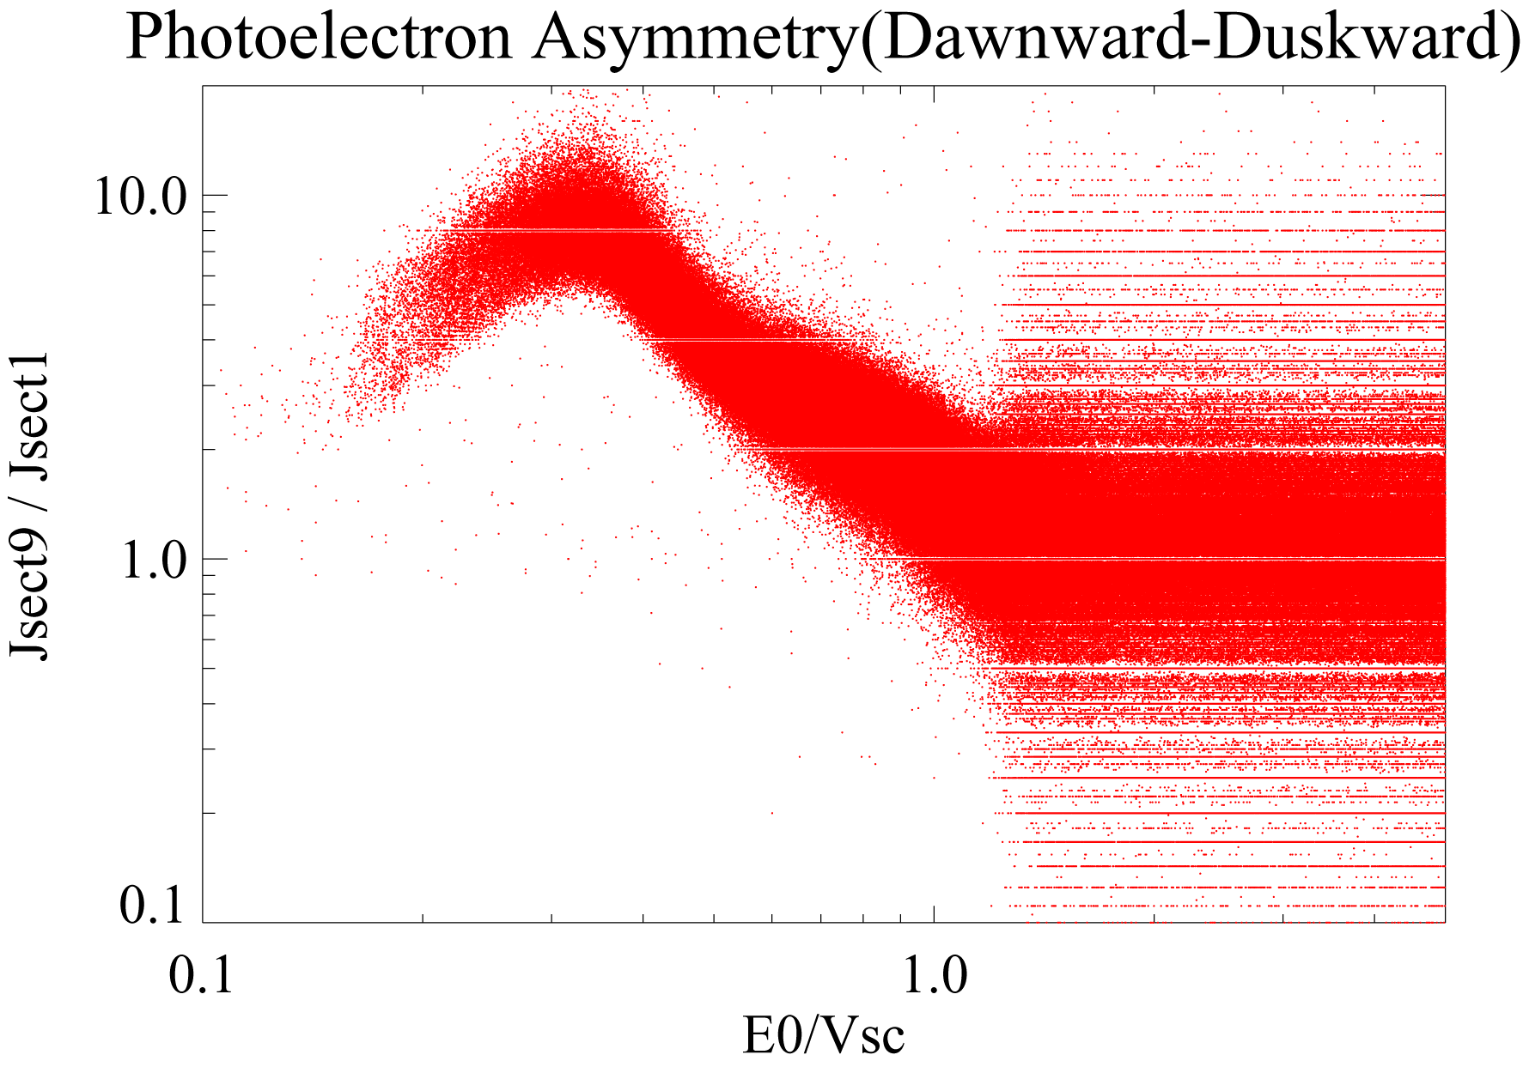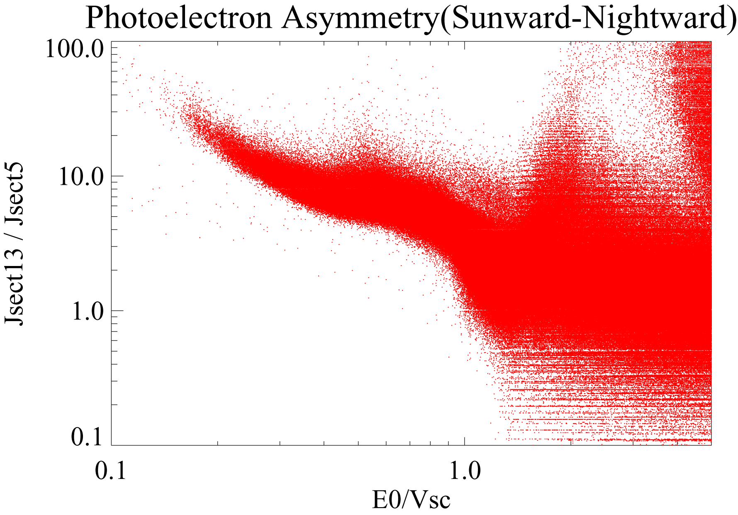
(a) (b)

Figure 6. Dependence of asymmetry of photoelectron distribution on E₀/V_{sc}. (a) The ratio of duskward photoelectron flux to dawnward flux (J_{sect9}/J_{sect1}). (b) The ratio of tailward flux to sunward flux (J_{sect13}/J_{sect15}).

because the Debye length of photoelectrons and ambient electrons around GEOTAIL are 4.7m for 6V < V_{sc} < 25V (Nakagawa et al., 2000) while that of ambient electrons in the magnetosphere is 100 m - 1 km (Baumjohann and Treumann, 1997). Therefore $λ_{D}≈$4.7m around GEOTAIL and the magnitude of the radial electric field is ${V_{\text{sc}}}/{λ_{D}}≈$1V/m, which is much larger than the ambient electric field. Hence the effect of ambient electric field is also negligible.
Previous discussions support the idea that the asymmetry of photoelectron distribution is caused by the azimuthal electric field around the spacecraft. Nevertheless, the two masts, which are also in the same potential as the spacecraft body, are deployed symmetrically with respect to the field-of-view of LEP/EA-e (Figure 2) and four wires coated by polyimide are too thin to disturb the electric field around GEOTAIL. Therefore the cause of such azimuthal electric field is not clear yet. The precise structure of electric and magnetic fields near the spacecraft body should be understood.

6. Summary and Conclusion
In this paper, the two-dimensional photoelectron distribution around GEOTAIL and its dependence on the spacecraft potential were statistically studied using the data obtained from LEP/EA-e and EFD-P when GEOTAIL was in Earth’s magnetosphere.
An asymmetry of the photoelectron distribution was found in the dawn-dusk direction as well as the day-night direction. We further found that the asymmetry depends strongly on the ratio of photoelectron energy to the spacecraft potential. The ratio of the duskward photoelectron flux to the dawnward flux is largest when the photoelectron energy is about one third of the spacecraft potential, although the ratio of the tailward flux to the sunward flux of photoelectrons monotonically decreases as the ratio of photoelectron energy to the spacecraft potential increases.
Since the effect of ambient magnetic and electric fields are considered to be negligible, the asymmetry of photoelectron distribution is suggested to be due to the azimuthal electric field generated by the spacecraft potential. However, the generation mechanism of such electric field is still an open question.

References
Baumjohann, W., and R. A. Treumann, Basic Space Plasma Physics, Imperial College Press, 1997
Harvey, C., C., J. Etcheto, J. DeJavel, R. Manning and M. Petit, ISEE electron density experiment, IEEE Trans. Geosci. Electron., GE-16, 231-238, 1978
Hilgers, A., B. Holback, G. Holmgren and R. Boström, Probe measurements of low plasma densities with applications to the auroral acceleration region and auroral kilometric radiation sources, J. Geophys. Res., 97, 8631-8641, 1992
ISAS Data Center, GEOTAIL Prelaunch Report, 1992
Mukai, T., S. Machida, Y. Saito, M, Hirahara, T. Terasawa, N. Kaya, T. Obara, M. Ejiri and A. Nishida, The low energy paricle (LEP) experiment onboard the GEOTAIL satellite, J. Geomag. Geoelectr., 46, 669-692, 1994
Nakagawa, T., T. Ishii, K. Tsuruda, H. Hayakawa and T. Mukai, Net current density of photoelectrons emitted from the surface of the GEOTAIL spacecraft, Earth Planets Space, 52, 283-292, 2000
Nakamura, R., S. Kokubun, T. Mukai and T. Yamamoto, Changes in the distant tail configuration during geomagnetic storms, J. Geophys. Res., 102, A5, 9587-9601, 1997
Nishida, A., The GEOTAIL mission, Geophys. Res. Lett., 21, 2871-2873, 1994
Pedersen, A., Solar wind and magnetosphere plasma diagnostics by spacecraft electrostatic potential measurements, Ann. Geophysicae, 13, 118-129, 1995
Pedersen, A., Mozer, M. and Gustafsson, G., Electric field measurements in a tenuous plasma with spherical double probes, in Pftaff, F. P., Borovsky, J. E. and Young, D. T. (Eds.), Measurement Techniques in Space Plasmas: Fields, Geophys. Monograph, 103, 1-12, 1998
Tsuruda, K., H. Hayakawa, M. Nakamura, T. Okada, A. Matsuoka, F. S. Mozer and R. Schmidt, Electric field measurements on the GEOTAIL satellite, J. Geomag. Geoelectr., 46, 693-711, 1994
Thiébault, B., A. Hilgers, E. Sasot, H. Laakso, P. Escoubet, V. Genot and J. Forest (2004), Potential barrier in the electrostatic sheath around a magnetospheric spacecraft, J. Geophys. Res., 109, A12207, doi:10.1029/2004JA010398

